**DETAIL DESIGN**



**Author: IMAGINEERS**

**Date: 10/02/2017**

**Revision history**

|  |  |  |  |
| --- | --- | --- | --- |
| **Version** | **Date** | **Author** | **Notes** |
| **1.0** | 10/12/2017 | Viet Dang | Created |
| 2.0 | 09/03/2017 | Phuong Nguyen | Updated create profile |
|  |  |  |  |
|  |  |  |  |

Contents

I. INTRODUCTION 4

II. PROTOTYPE 4

1. SWAPPAL_REGISTERACCOUNT 4

1.1 Register 4

1.2 Login 4

2 SWAPPAL_PROFILE 6

2.1 My Page 6

2.2 Edit My Page 7

2.3 About me 8

2.4 Edit About me 10

2.5 View review detail 11

2.6 Create profile 12

# INTRODUCTION

This document is created to show the design GUI or sketches of the Swappal website. This document is create for

* Scrum Team
* Product Owner

# PROTOTYPE

## SWAPPAL_REGISTERACCOUNT

### Register

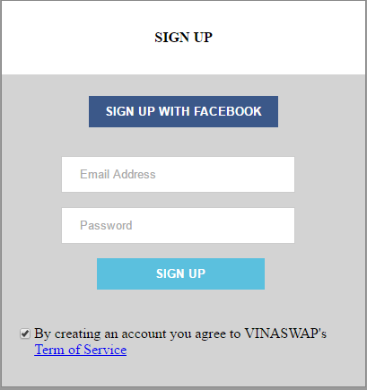

### Login

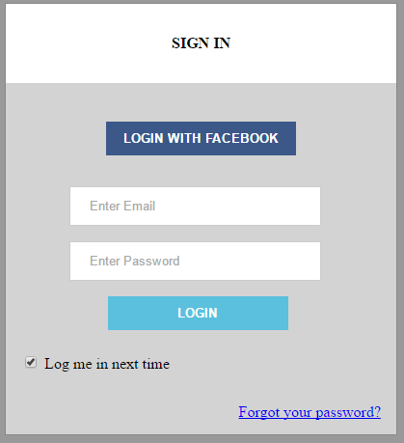

## SWAPPAL_PROFILE

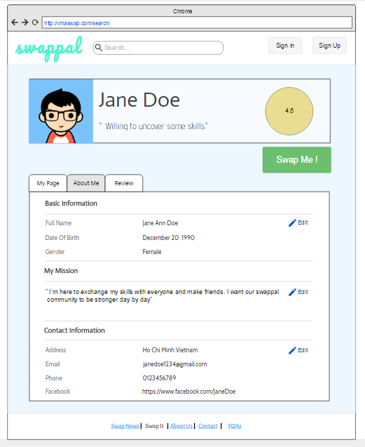

### My Page

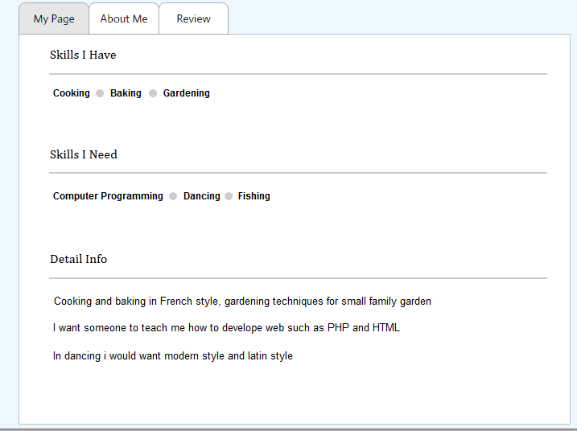

### Edit My Page

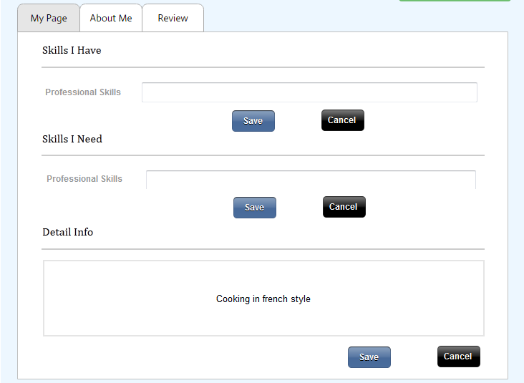

### About me

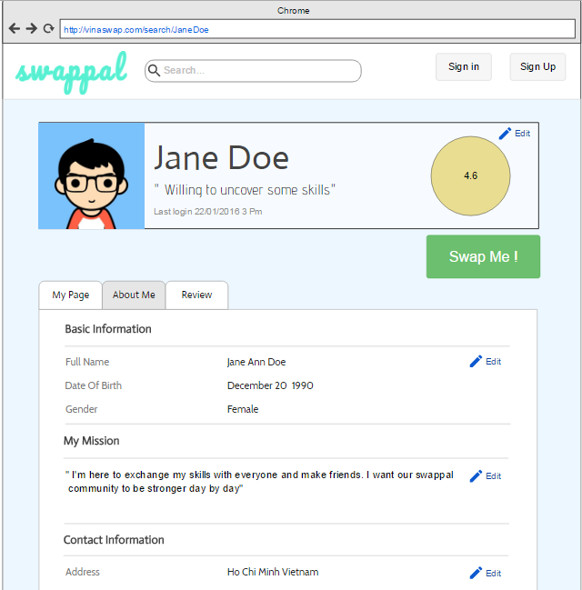

### Edit About me

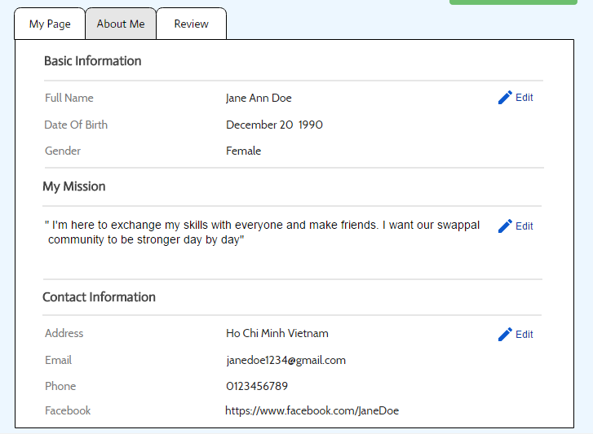

### View review detail

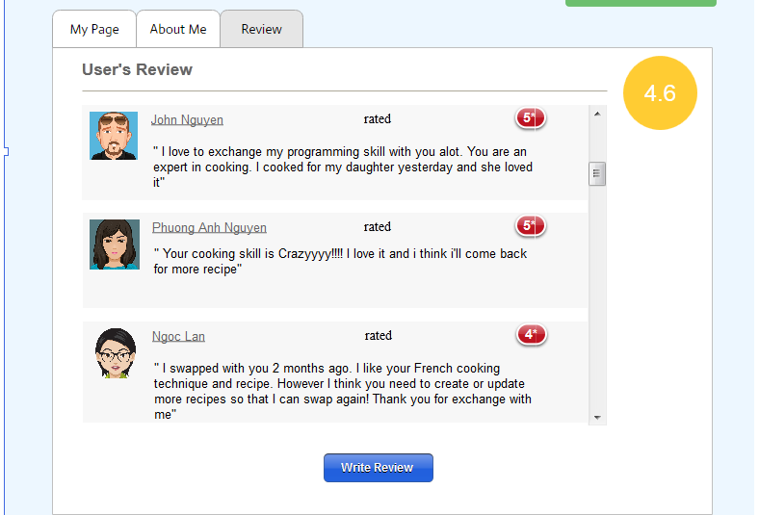



### Create profile

